Tableau Basics Assignment
Name: Rahul Sharma

Question1.
Explain what Tableau is and why it is preferred over traditional spreadsheet tools for data analysis. Also mention any two industries where Tableau is commonly used and explain one use case.
Ans.
Tableau is a data visualization and business intelligence tool that helps users analyze, interpret, and present data in an interactive and visually engaging way. Unlike traditional spreadsheet tools such as Excel, Tableau is designed specifically for data exploration and storytelling, allowing users to connect to large datasets, perform advanced analytics, and create dashboards without heavy coding.
Why Tableau is Preferred Over Spreadsheets
Scalability: Handles millions of rows of data efficiently, whereas spreadsheets often struggle with large datasets.
Visualization Power: Offers advanced charts, maps, and interactive dashboards beyond the static graphs in spreadsheets.
Ease of Use: Drag-and-drop interface makes complex analysis accessible to non-technical users.
Data Connectivity: Connects directly to databases, cloud services, and live data sources, ensuring real-time insights.
Collaboration: Dashboards can be shared across teams and embedded in applications, unlike spreadsheets which are often siloed.
Industries Where Tableau is Commonly Used
Healthcare
Used for patient data analysis, hospital performance tracking, and resource allocation.
Retail & E-commerce
Applied in sales analysis, customer segmentation, and supply chain optimization.
Example Use Case: Retail Industry
Imagine a large retail chain using Tableau to analyze customer purchase behaviour.
They connect Tableau to their sales database.
Create dashboards showing top-selling products, seasonal trends, and regional performance.
Use interactive filters to drill down into customer demographics and purchase channels.
Business impact: The company identifies underperforming regions, optimizes inventory, and tailors marketing campaigns to specific customer segments.
Question2.
After connecting to the Sample – Superstore dataset:
a) List the main types of fields available (examples: time-based, geographical, numerical).
b) Identify any four Dimensions and any four Measures from the dataset.
Hint: Look at the Data Pane on the left side of Tableau and observe blue (Dimensions) and green (Measures) fields.
Ans.
(a) Main Types of Fields in Tableau
When you connect to the dataset, Tableau automatically classifies fields into Dimensions (qualitative/categorical) and Measures (quantitative/numeric). Broadly, these fall into:
Time-based fields e.g., Order Date, Ship Date
Geographical fields e.g., Country, City, State, Postal Code
Numerical fields e.g., Sales, Profit, Quantity, Discount
Textual/Categorical fields e.g., Category, Sub-Category, Segment, Ship Mode
(b) Dimensions vs. Measures
In Tableau, blue fields = Dimensions (used for slicing data), and green fields = Measures (used for aggregation and calculations).
Four Dimensions (examples from Superstore):
Order Date (time-based)
Category (product classification)
Region (geographical)
Customer Name (textual/categorical)
Four Measures (examples from Superstore):
Sales (numeric, aggregated as SUM)
Profit (numeric, aggregated as SUM)
Quantity (numeric, aggregated as SUM)
Discount (numeric, aggregated as AVG or SUM)
Dimensions help you break down data into meaningful categories (e.g., sales by Region or Category).
Measures provide the actual values you want to analyze (e.g., total Sales, average Discount).
Together, they allow you to build interactive dashboards that reveal trends, comparisons, and insights at multiple levels of detail.
Dimensions compare to fact/dimension tables in star schema)? That way, you’ll see the parallels more clearly.

Question3.
Create a Bar Chart showing Total Sales by Category. Explain: Which field goes to Rows Which field goes to Columns Which aggregation is applied to Sales.
Hint: Drag Category and Sales into the view and observe Tableau’s default behaviour.
Ans.
Rows: Place Category here.
Tableau treats Category as a dimension, so it creates one row for each unique category (Furniture, Office Supplies, Technology in the Superstore dataset).
Columns: Place Sales here.
Tableau recognizes Sales as a measure, so it automatically applies an aggregation.
Aggregation applied to Sales: By default, Tableau uses SUM(Sales).
This means it adds up all sales values for each category, giving you total sales per category.
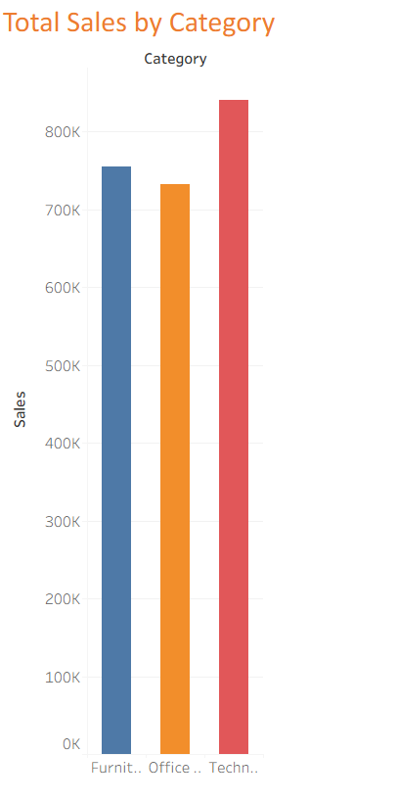

Question4.
What insight can be gained by comparing Sales and Profit together? Then explain how you would create a chart to analyze Profit by Sub-Category.
Hint: Use Sub-Category as a Dimension and Profit as a Measure.
Ans.
Comparing Sales and Profit together is powerful because it reveals not just how much revenue each category or sub-category generates, but also whether that revenue is actually profitable.
Insights from Sales vs. Profit
A sub-category might have high sales but low (or negative) profit, indicating issues like heavy discounts, high costs, or inefficiencies.
Another sub-category could have moderate sales but strong profit margins, showing it’s more efficient or strategically valuable.
This comparison helps identify where the business should focus—boosting profitable areas or fixing problem areas where sales don’t translate into profit.
Chart: Profit by Sub-Category in Tableau
Here’s how you would build it:
- Dimension (Rows): Drag Sub-Category to the Rows shelf.
Tableau treats Sub-Category as a dimension, so each unique sub-category (e.g., Chairs, Phones, Binders) gets its own row.
- Measure (Columns): Drag Profit to the Columns shelf.
Tableau recognizes Profit as a measure and applies the default aggregation SUM(Profit).
- Visualization: Tableau will automatically create a bar chart showing total profit for each sub-category.
Bars extending to the left (negative values) highlight sub-categories with losses.
Bars extending to the right (positive values) show profitable sub-categories.
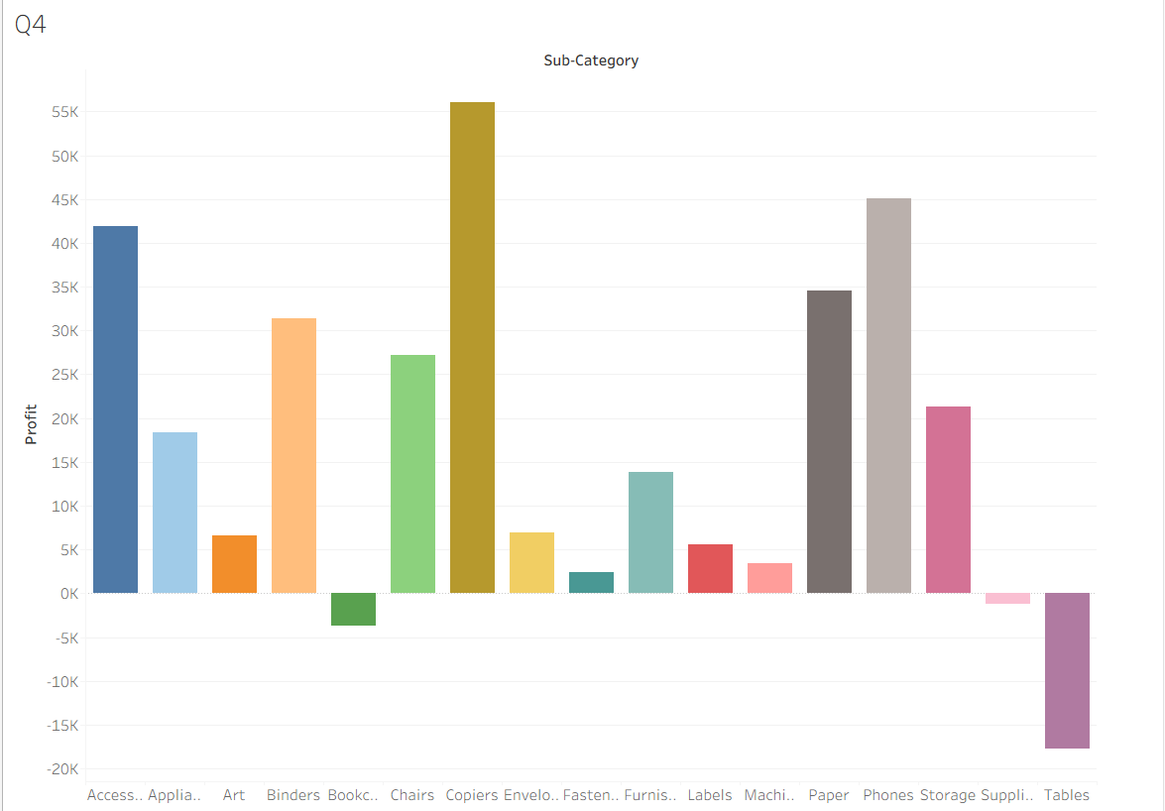

Question5.
Create a Line Chart to show Sales Trend over Order Date. Which date level would you choose (Year / Quarter / Month)? Why are line charts suitable for time-based analysis?
Hint: Drag Order Date and change its date hierarchy from Year to Month if needed.
Ans.
Best choice: Month (continuous)
Year alone gives a very high-level view (only 4 points if you have 4 years of data).
Quarter is more detailed but still coarse.
Month shows seasonal patterns, peaks, and dips across time, making it ideal for spotting trends in sales behaviour.
You can still drill up to Quarter or Year if you want broader context.
Why Line Charts Work for Time-Based Analysis
- Line charts emphasize continuity over time, showing how values rise or fall across sequential dates.
- They make it easy to detect trends, cycles, and anomalies (e.g., holiday spikes, sudden drops).
- The connected points highlight the direction and momentum of change, which bar charts or scatter plots don’t convey as clearly.

Steps in Tableau
- Drag Order Date to the Columns shelf.
Right-click and choose Month from the date hierarchy.
- Drag Sales to the Rows shelf.
Tableau applies SUM(Sales) by default.
- Tableau automatically creates a line chart showing monthly sales trends.
If it defaults to a bar chart, switch the Marks type to Line.

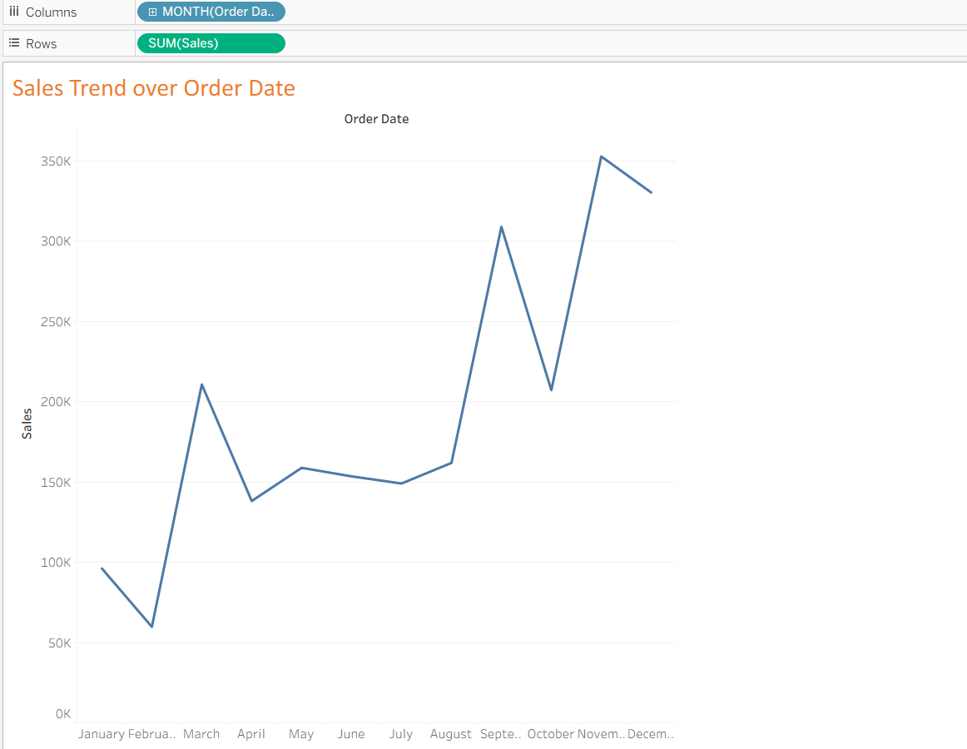
Question6.
Apply a Basic Filter to display data only for: Region = “West” Category = “Technology” Explain the steps and mention which shelf is used. Hint: Drag the required fields to the Filters shelf and select appropriate values.
Ans.
Steps
- Drag Region to the Filters shelf
Tableau will open a filter dialog.
Select West from the list of available regions.
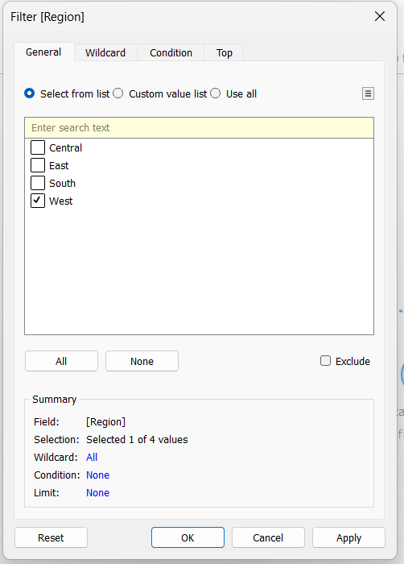
- Drag Category to the Filters shelf
Again, Tableau will prompt you to choose values.
Select Technology from the available categories.
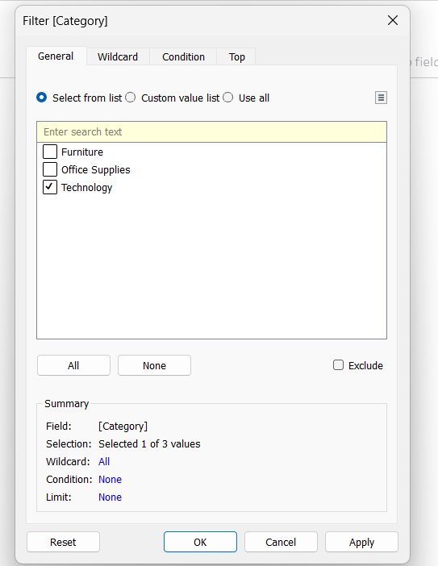
- Confirm filters
Both filters now appear in the Filters shelf.
The view updates to show only data where Region = West and Category = Technology.
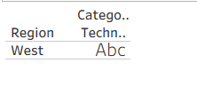
Shelf Used
The Filters shelf is where you place these fields.
This shelf controls which subset of data is displayed in the visualization.

Question7.
Explain the business importance of geographical analysis. Then describe how you would create a Map showing Sales by State using Sample – Superstore. Hint: Use State and Sales. Tableau automatically detects geographic fields.
Ans.
Business Importance of Geographical Analysis
- Regional performance insights: It helps businesses see which areas are driving revenue and which are underperforming.
- Targeted strategy: Marketing, distribution, and resource allocation can be tailored to regions with high demand or profitability.
- Trend detection: Geographical analysis can reveal regional preferences, seasonal demand shifts, or areas impacted by external factors (e.g., logistics, competition).
- Decision-making: Leaders can prioritize investments, optimize supply chains, and identify growth opportunities based on location-specific data.

Creating a Map of Sales by State in Tableau (Sample – Superstore)
- Dimension (Geographic field): Drag State to the Rows shelf or directly onto the canvas.
Tableau automatically recognizes State as a geographic dimension (shown with a globe icon).
- Measure: Drag Sales to Size or Colour on the Marks card.
Tableau applies SUM(Sales) by default, showing total sales per state.
3. Visualization: Tableau generates a filled map (or symbol map depending on your choice).
Each state is shaded or sized according to its total sales.
Darker colors or larger circles represent higher sales.
- Optional Enhancements:
- Add Profit to color for a dual insight (profitable vs. unprofitable states).
- Use Filters (e.g., Region = West) to narrow the view.
- Add labels to display exact sales values.
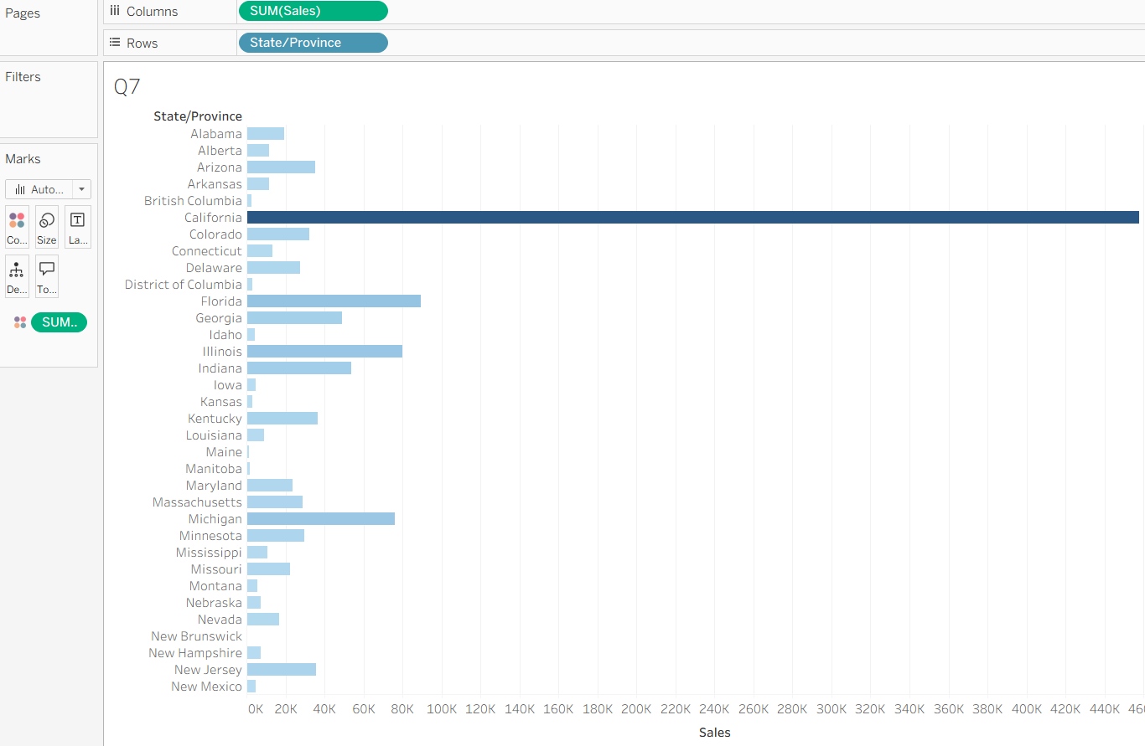

Question8.
What is the difference between a Worksheet and a Dashboard in Tableau? Why is a dashboard more useful for decision-makers?
Ans.
Difference Between Worksheet and Dashboard in Tableau
Worksheet
A single view containing one visualization (e.g., bar chart, line chart, map).
Built from dimensions, measures, and filters placed on shelves.
Useful for exploring one aspect of the data at a time.
Dashboard
A collection of multiple worksheets and other objects (like text, images, filters) arranged together.
Provides a consolidated view where users can interact with multiple charts simultaneously.
Enables comparisons, storytelling, and interactive filtering across different visualizations.

Why Dashboards Are More Useful for Decision-Makers
Holistic view: Dashboards combine multiple perspectives (sales trends, profit margins, regional performance) in one place.
Interactivity: Filters, parameters, and actions allow decision-makers to drill down into details and explore scenarios.
Efficiency: Instead of flipping through separate worksheets, leaders can see the big picture and key metrics at a glance.
Storytelling: Dashboards highlight relationships between different metrics, making insights clearer and more persuasive.

Question9.
What is Tableau Prep, and why is it important in real-world data projects? Then explain how you would: Remove null values Remove duplicate records Change incorrect data types (Answer in steps, no tool access required.)
Ans.
Tableau Prep
Tableau Prep is Tableau’s data preparation tool.
It allows you to clean, shape, and combine data before analysis in Tableau Desktop.
In real-world projects, raw data often contains nulls, duplicates, inconsistent formats, and incorrect data types. Tableau Prep helps fix these issues so dashboards and reports are reliable.
It’s important in real-world projects
- Data quality: Ensures accurate insights by removing errors and inconsistencies.
- Efficiency: Automates repetitive cleaning tasks, saving analysts time.
- Integration: Prepares data from multiple sources into a single, analysis-ready dataset.
- Trust: Decision-makers can rely on dashboards built on clean, validated data.
Steps in Tableau Prep
Remove Null Values
Drag the dataset into Tableau Prep.
Select the field with nulls.
Use the Filter option - Exclude Null Values.
Alternatively, replace nulls with default values if needed (e.g., “Unknown”).
Remove Duplicate Records
Identify duplicates by selecting key fields (e.g., Order ID, Customer ID).
Use the Remove Duplicates option in the cleaning step.
Tableau Prep keeps only unique rows based on your chosen fields.
Change Incorrect Data Types
Click on the field name in the profile pane.
Tableau Prep shows the current data type (e.g., string, number, date).
Change it to the correct type (e.g., convert “123” stored as text into a number, or fix dates stored as strings)

Question10.
A retail manager wants answers to the following: Which category generates the highest profit? Which region performs poorly? How does sales change over time?
a) Mention which charts you would use
b) Identify one key insight that management could derive
c) Explain how this helps in business decision-making.
Ans.
(a) Charts to Use
- Which category generates the highest profit?
Bar Chart of Profit by Category (easy comparison across categories).
- Which region performs poorly?
Map or Bar Chart of Profit by Region (geographical view highlights weak areas).
- How does sales change over time?
Line Chart of Sales over Order Date (Month/Year) (shows trends, seasonality, growth/decline).
(b) Key Insight for Management
- Example: Furniture generates high sales but low profit, while Technology is consistently profitable. The West region underperforms compared to others, and sales show strong seasonal peaks at year-end.
This kind of insight reveals mismatches between revenue and profitability, as well as regional weaknesses.
(c) Business Decision-Making Impact
- Resource Allocation: Focus marketing and inventory on profitable categories like Technology.
- Regional Strategy: Investigate why the West region is underperforming (logistics, competition, pricing) and take corrective action.
- Forecasting & Planning: Use sales trends to plan promotions, staffing, and stock levels during peak months.

